Today we have the meeting with Klaus Ryttov, so below are the main points of discussion.

1. We have to share only nfs share point details in task of online storage ( auto.direct details no longer required).

2. We have to check both commands **df -hTP| grep -i nfs** & **df -hTP** and attached to the storage task

a) if we found evs or EVS is involved in the storage host-name then HNAS is involved and we have to add task for online storage.

b) if we found Ip (for e.g- 10.104.78.2) in nfs share point output then we have to search ip in infoblox portal- <https://infoblox/ui/> and have to provide name field with ip in CRQ task as shown below-

for example- 10.104.78.2:/com2sop_export (voe-p-evs01)

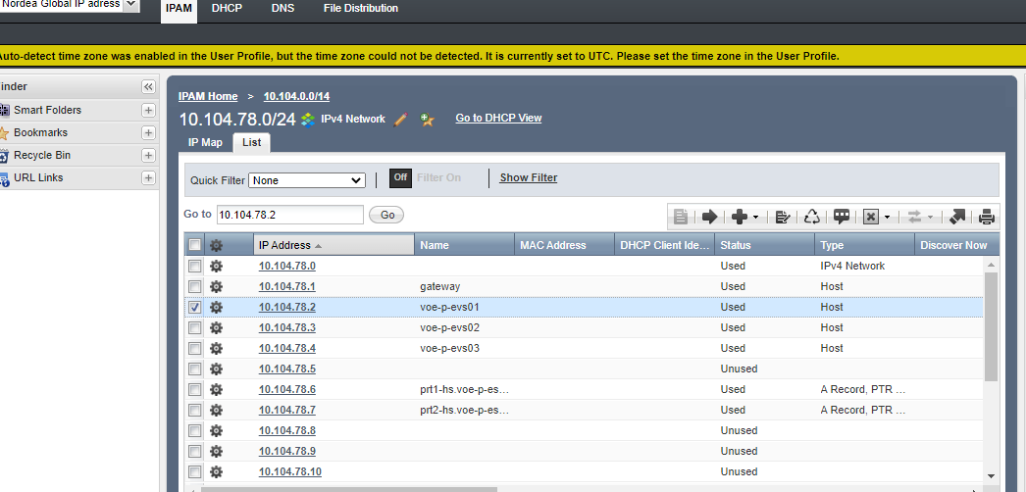

3. We have to inform about actual migration timings to Klaus Ryttov for any migration (which involve HNAS) and if by any chance we have to rollback that migration then again we have to inform so that they can revert back the old ip.

4. We have to open the BAU Task as usual and we don’t have to close the task without written BAU confirmation.